Temasek Polytechnic
School of Informatics and IT

Diploma in Information Technology (IT)

Software Design Specifications (DS)

Project Particulars

Tutor | Mr Mel Goh
Class | P03
Project Title | Delonix Regia Hotel Management System

Project Team’s Particulars

Matric Number | Student Name
1402366G | Sin Jun Jie
1400897C | Nigel Yee Wei Peng
1406959E | Muhd Riduwan Bin Zainudin
1405153F | Muhd Zulafandi Bin Yazab

Revision History

Date | Version | Description | Author
<dd/mm/yy> | <x.x> | <details> | <name>

Table of Contents

1. DISTRIBUTION OF WORKLOAD 4
2. ARCHITECTURE DESIGN 4
3. USER INTERFACE (UI) DESIGN 9
4. PROGRAM DESIGN 12
5. DATABASE DESIGN 18

DISTRIBUTION OF WORKLOAD

Design | Members
Database Design | Sin Jun Jie
User Interface Design | Nigel Yee Wei Peng
Architecture Design | Muhd Riduwan Bin Zainudin
Program Design | Muhd Zulafandi Bin Yazab

ARCHITECTURE DESIGN

Software design is the design patterns and frameworks that promote design and code reuse in software development.
There are 4 types of architecture design:
- Standalone Application
- 2-Tier Architecture
- 3-Tier Architecture
- N-Tier Architecture

Standalone Application
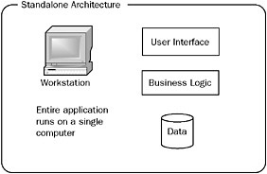
The diagram above illustrates a standalone architecture. A Standalone application can work offline, as it does not necessarily require network connection to function. A standalone application run as a separate computer process, not an add-on of an existing process.

Benefits:
-The benefits of a standalone application is damage control, in a situation whereby something goes wrong, only the standalone will be affected. A standalone does not affect other computer users
-Requires less expertise to manage one computer than it does to set-up or troubleshoot several.

Pitfalls:
-If something goes wrong with the file server, the whole network is unable to operate, therefore. Mr Wang could lose all of his information and may results of losing sales.

Two-tier Architecture

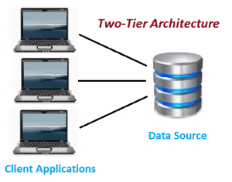
Description
The two-tier architecture is also known as the client server application whereby a direct communication takes place between client and server. There is no intermediate between client and server. Two-tier are able to run faster due to tight coupling.

How Does It Work?
An example would be two guest wants to reserve the same room at the same time. Therefore this could cause confusion for the receptionists who are searching for the room availability. However, this is how the 2-tier solve the problem, in this case the receptionist will enter data to Client Application and reservation request is send to the database. Then, the database will send back the data to the client. In this application the receptionist is the end user which provide inputs to the application software and sends request to the server. Hence, both Database and Server are incorporated with each other. This is called “Client-Server Technology’.

The two-tier architecture consists of two parts:
- Client Application(Client Tier)
- Database(Data Tier)

Benefits:
-Easy to maintain and modification is bit easy
-Faster communication

Pitfalls:
-Performance will degrade due to increasing users in two tier architecture application
-Cost-ineffective

Three-tier Architecture
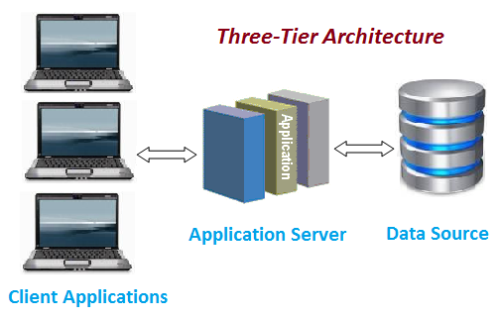

Description
The three tier architecture consist of a presentation tier, a business or data access tier, and a data tier.

The three layers are:
1) Client layer
- Known as presentation layer which includes User Interface part of the application
- Utilized for the design purpose where data is displayed to the user or input is taken from the user
-An example would be designing a registration form that contains text box, label or button.

2) Business layer
-Acts as an interface between Client layer and Data Access Layer
-Known as the intermediary layer which assist to make communication faster between client and data layer.

3) Data layer
- Contains methods to connect with database and to perform insert, update, delete, get data from database based on the input data.

Benefits:
-High performance, lightweight persistent objects
-Scalability – Each tier can scale horizontally
-Performance – Because the Presentation tier can cache requests, network utilization is minimized, and the load is reduced on the Application and Data tiers.
-High degree of flexibility in deployment platform and configuration
-Better Re-use
-Improve Data Integrity
-Improved Security – Client is not direct access to database.
-Easy to maintain and modification is bit easy, won’t affect other modules

Pitfalls
-Setting up three tier can be complex as it can be time consuming
-IT specialist or programmers are needed for object oriented concept (classes and objects).

How does it work?
Presentation layer allows user to design their interface using html web controls or windows controls. This can be the user’s website or the users windows application. This layer can only communicate with the business layer.

The Application layer or Business Layer is the middle layer that connects both database layer and presentation layer. In this layer, users can write their business logic, an example would be their business requirement. This layer communicates with both database layer and presentation layer.

The Database layer is the one that make connections to the database server. Users are able to write database connection, sql queries or stored procedures. This layer only communicates with business layer.

The process on how the three tier architecture works is for example when users post any data from the presentation page, the data will first proceed to the business layer. From there, the data will be validated. Once data is validated, the validated data is posted to the database layer which will then be inserted into the database. If the user wants to request any data from the database, the request will be first process by the business layer. The business layer will validate the request and send it to the database layer. Then, the database layer will forward it to the database server and retrieve its necessary records. Once the records are found, the records will be loaded by the database layer and will pass it back to the business layer. Finally, the business layer will pass the records to the presentation layer.

N-tier architecture
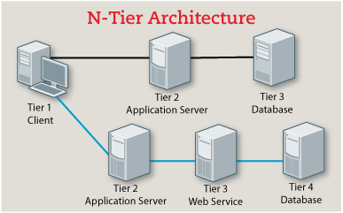
Description
An n-tier architecture refers to the number of components in an application. The diagram above illustrates a three-tier setup which is the top, Service Oriented Architecture(SOA) can have three or more tiers plus multiple service path which is the bottom. However application delivery systems must account for all the tiers.

Benefits:
- Increase in performance due to off-load from the database tier and the client tier, enabling it to suit medium to high
-Reduce infrastructure cost by using redundant arrays to meet performance and availability requirements

Pitfalls:
-Due to the componentization of tiers, the complex structure is hard to implement or maintain

How does it work?
The n -tier application includes a presentation tier, a middle tier, and a data tier. The simplest way to separate the different tiers in an n-tier application is to create discrete projects for each tier that users wants to include in their application. For example, the presentation tier might be a Windows Forms application, whereas the data access logic might be a class library located in the middle tier. Additionally, the presentation layer might communicate with the data access logic in the middle tier through a service such as a service. Separating application components into separate tiers increases the maintainability and scalability of the application. It does this by enabling easier adoption of new technologies that can be applied to a single tier without the requirement to redesign the whole solution. In addition, n-tier applications typically store sensitive information in the middle-tier, which maintains isolation from the presentation tier.

Proposed System Architecture

The proposed system architecture would be the standalone application. As this is what Mr Wang needs for his architecture. The benefits of a standalone application is damage control,in a situation whereby something goes wrong, only the standalone will be affected. A standalone does not affect other computer users. It also requires less expertise to set up the the standalone application.

USER INTERFACE (UI) DESIGN
A user interface design provides a visual overview, comprising of the screens which typically includes, messages, imagery, link etc. for websites, computers, appliances, machines, mobile devices, and software applications with a focus of delivering great user experiences and interaction.
User interfaces can be classified into the following 3 categories:
- Command language based interface
- Menu-based interface
- Direct manipulation interface

Command language-based interface
As the name itself suggests, it is based on designing a command language which the user can use to issue the commands. The user is expected to frame the appropriate commands in the language and type them in appropriately whenever required. A simple command language-based interface might simply assign unique names to the different commands. However, a more sophisticated command language-based interface may allow users to compose complex commands by using a set of primitive commands. Such a facility to compose commands dramatically reduces the number of command names one would have to remember. Thus, a command language-based interface can be made concise requiring minimal typing by the user. Command language-based interfaces allow fast interaction with the computer and simplify the input of complex commands.

Menu-based interface
An important advantage of a menu-based interface over a command language-based interface is that a menu-based interface does not require the users to remember the exact syntax of the commands. A menu-based interface is based on recognition of the command names, rather than recollection. Furthermore, in a menu-based interface the typing effort is minimal as most interactions are carried out through menu selections using a pointing device. This factor is an important consideration for the occasional user who cannot type fast.

However, experienced users find a menu-based user interface to be slower than a command language-based interface because an experienced user can type fast and can get speed advantage by composing different primitive commands to express complex commands. Composing commands in a menu-based interface is not possible. This is because of the fact that actions involving logical connectives (and, or, etc.) are awkward to specify in a menu-based system. Also, if the number of choices is large, it is difficult to select from the menu. In fact, a major challenge in the design of a menu-based interface

Direct manipulation interface
Direct manipulation interfaces present the interface to the user in the form of visual models (i.e. icons or objects). For this reason, direct manipulation interfaces are sometimes called as iconic interface. In this type of interface, the user issues commands by performing actions on the visual representations of the objects, e.g. pull an icon representing a file into an icon representing a trash box, for deleting the file. Important advantages of iconic interfaces include the fact that the icons can be recognized by the users very easily, and that icons are language-independent. However, direct manipulation interfaces can be considered slow for experienced users. Also, it is difficult to give complex commands using a direct manipulation interface. For example, if one has to drag an icon representing the file to a trash box icon for deleting a file, then in order to delete all the files in the directory one has to perform this operation
individually for all files.

Proposed UI
We have decided to use Web application for the UI, as web applications are popular and easily accessible with the several web browsers on the market. A web-based application is any application that uses a website as the interface (the ‘front-end’). Users access the application from any computer connected to the Internet using a standard browser, instead of using an application that has been installed on their local computer.

For instance, most of us are familiar with Microsoft Word, a common word-processing application. Google Docs is also a word-processing application, however, users perform all the functions using any web browser instead of using software installed on their computer. Web-based e-mail such as Gmail is another common web-based application that performs the same functions as a traditional desktop application.

Web-based User Interface (WUI) accepts input and provide output by generating web pages which are transmitted via the Internet and viewed by the user using a web browser program. Newer implementations utilize Java, JavaScript, AJAX, Apache Flex, .NET Framework, or similar technologies to provide real-time control in a separate program, eliminating the need to refresh a traditional HTML based web browser. Administrative web interfaces for web-servers, servers and networked computers are often called control panels. The user interface of web-based applications is easier to customize than it is in desktop applications. This makes it easier to update the look and feel of the application, or to customize the presentation of information to different user groups.

With web-based applications, users access the system via a uniform environment the web browser. Though, the user interaction with the application needs to be thoroughly tested on different web browsers, the application itself needs only be developed for a single operating system. There’s no need to develop and test it on all possible operating system versions and configurations. This makes development and troubleshooting much easier, and for web applications that use a Flash front end, testing and troubleshooting is even easier. Using internet technologies based on industry-wide standards, it is possible to achieve a far greater level of interoperability between applications than with individual desktop systems. For example, it is much easier to integrate a web-based booking system with a web-based accounting package than it is to get two proprietary systems to talk to each other. Web-based architecture makes it possible to rapidly integrate enterprise systems, improving work-flow and other business processes.
UI Design
Interface elements include but are not limited to:
- Input Controls: checkboxes, radio buttons, dropdown lists, list boxes, buttons, toggles, text fields, date field.
- Navigational Components: breadcrumb, slider, search field, pagination, slider, tags, icons
- Informational Components: tooltips, icons, message boxes, notifications, progress bar.
To create an optimal user interface, the design has to be consistent, simple and efficient, in terms of completing user tasks. It requires a good understanding of the user’s needs. Typically, this can be achieved by carrying out a functionality requirements gathering. This means to assemble a list of the functionalities required by the system and implementing them to accomplish the goals of the project and catering the potential needs of the users.

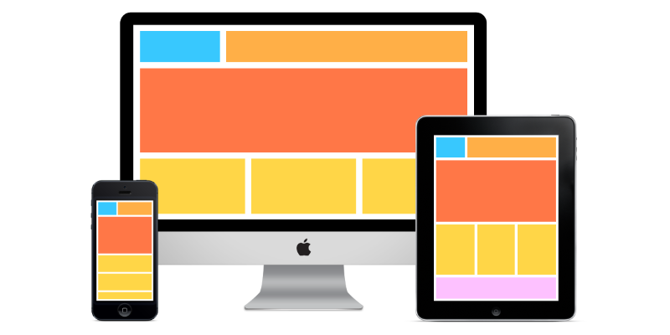

It is also important that the UI looks as seamless as possible across a broad range of different devices such as computers, smartphones and tablets.

These users will request the system to complete a function be navigating through the user interface, and the system will respond to the user requests and responses through the user interface implementation. There could also be helpful tips displayed in an overlay to guide the user in learning to use the system.

Below is a prototype of the main page in the user interface of Delonix Regia Hotel System:
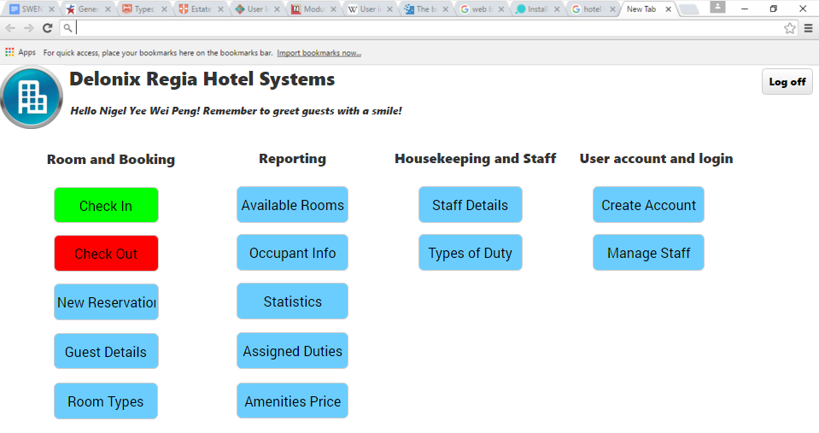

Main page provides an overview of all the functions that is to be implemented to the system. The rest of the pages aim to provide consistency and ease of use to complete various tasks listed.

PROGRAM DESIGN

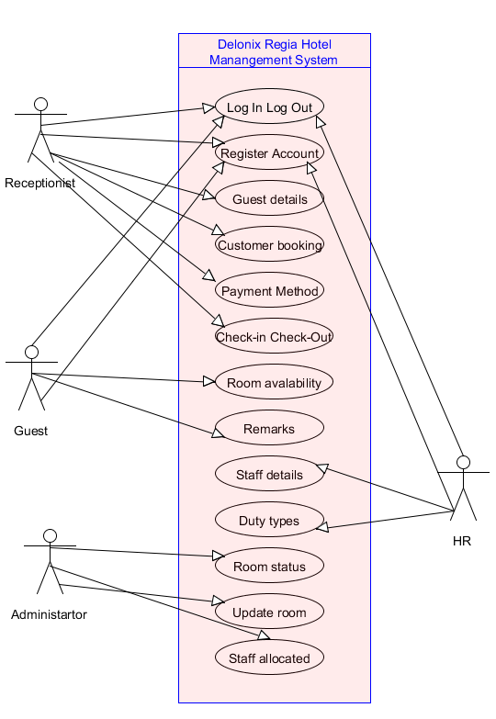

Use case 1: Register account
Brief description:Allow staff in hotel to register for an account in the management system
Actors; Receptionist, Guest, Administrator,HR
Flow of events:
Main Flow
- Use case start when user clicks on the register button
- System bring user to register page
- User will key in User details
- System process input then send verification to user
Alternative
Wrong Password
1. The system notify user that password not match
System under maintenance
- System under maintenance , message will prompt on screen

Use Case 2: Login account
Brief description: This use case allows users to log in to the hotel management system.
Actors: Receptionist, Room attendant, HR, Administrator
Flow of events:
Main flow:
1. This use case starts when the user clicks on the log in button.
2. System display the log in screen.
3. User enters their StaffId with their password to Log in into the system
4. Verifies the email address and password in database and will display homepage of the Delonix Regia’s system and the use case ends.
Alternative Flow 1:
Forget password
1. If the user forgets their password, they can click on the “forget password” button to reset their password
2. The administrator will then process their request and send an email to the user for verification of password reset
3. The user goes back to Step 1 of the main flow
Alternative Flow 2:
System under maintenance
1. If the system is under maintenance, a message will be displayed on the screen
2. The user goes back to Step 1 of the main flow

Use Case 3: Log out Delonix Regia Hotel Management System
Brief description: This use case allows the users to log out of the hotel management system
Actors: Receptionist, Administrator, Room attendant, HR
Flow of events:
Main Flow:
1. This use case starts when the user wants to out log out of the hotel management system
2. The user will click on the log out button
3. The system will then log the user out of the system

Use case 4: Customer Booking Delonix Regia Hotel Management System
Brief description: This use case allows the Receptionist to track the customer’s booking in Delonix Regia Booking system
Actor: Receptionist
Flow of events
Main Flow:
1. This use case starts when the staff check the customer booking in Delonix Regia Booking system
2. staff click on Booking system
3. The staff will enter their StaffId and password to log in to Booking System
4. System verify the StaffId and password
5. Redirect staff to Booking System page
6. The staff will key in the customer details to track their booking
7. System verifies the information and display booking details
Alternative Flow:
Reservation not made
1. System is unable to find any details
2. System will display “unable to find details”

Use case 5: Payment Method
Brief description: This use case allows the Receptionist and Guest to see or choose which payment they using
Actor: Receptionist, Guest
Flow of events
Main Flow:
1. This use case starts when the guest choose payment method
2. Guest will select credit card or cash
3. The staff will check what payment method guest choose
4. Staff then verify payment method
5. System checkout payment
Alternative Flow:
Credit card
1. Credit card expiry
2. Credit card limit over
Alternative Flow 2:
Cash
1. Insufficient cash

Use case 6: Check In check Out
Brief description: This use case allows the Receptionist to check guest check in and check out
Actor: Receptionist
Flow of events
Main Flow:
1. This use case starts when the receptionist check guest check in and check out
2. Receptionist update system record
Alternative Flow:
Check in check out system
1. System crash cannot check guest check in and check out

Use case 7: Room availability
Brief description: This use case allow guest to check room availability
Actor: Guest
Flow of events
Main Flow:
1. This use case starts when the guest search for room
2. Guest will choose room type
3. Guest than will book room
Alternative Flow:
Room Unavailability
1. Guest check room type
2. Room not available for booking

Use case 8: Remark
Brief description: This use case allow guest to leave remark
Actor: Guest
Flow of events
Main Flow:
1. This use case starts when the guest go to remarks page
2. Guest will type remarks in the text box
3. Guest than will sent using send button
Alternative Flow:
Remark
1. Guest internet down
2. Remarks page down for maintenance

Use case 9: Staff details
Brief description: This use case allow HR to check staff details
Actor: HR
Flow of events
Main Flow:
1. This use case starts when the HR check staff details
2. HR can create new staff user
3. HR can update staff details
Alternative Flow:
1. Cannot create staff because user exist
2. Staff details input wrong

Use case 10: Duty types
Brief description: This use case allow HR to check staff duty type
Actor: HR
Flow of events
Main Flow:in charge of duty which stuff
1. This use case starts when the HR check duty staff
2. HR check with staff is in charge of the duty types

Use case 11: Room status
Brief description: This use case allow administrator to check room status
Actor: Administrator
Flow of events
Main Flow:
1. This use case starts when the administrator check room status
2. Administrator will check if room is book ,reserve or available
3. Administrator will than update the system
Alternative Flow:
1. Overlapping of booking

Use case 12: Update Room
Brief description: This use case allow administrator to check update room
Actor: Administrator
Flow of events
Main Flow:
1. This use case starts when the administrator check update room
2. Administrator will check if update room is correctly update or not

Use case 13: Staff allocated
Brief description: This use case allow administrator to check staff allocated
Actor: Administrator
Flow of events
Main Flow:
1. This use case starts when the administrator check staff allocated
2. Administrator will check staff what duty they allocated too
Domain model

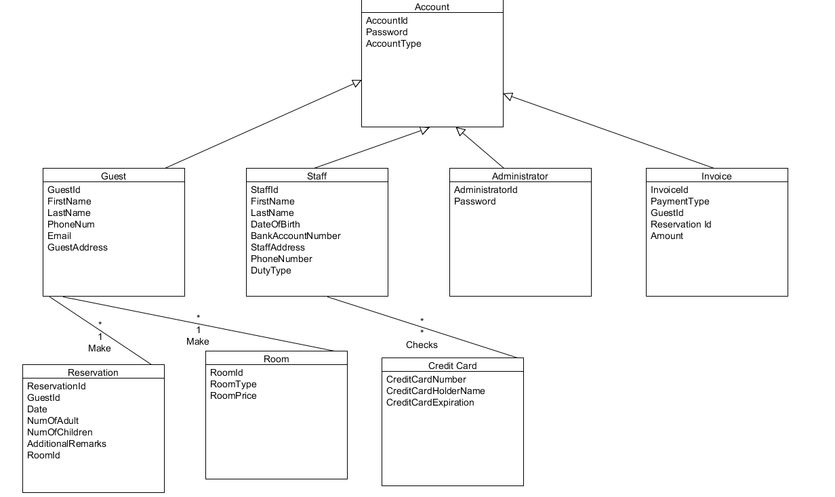

DATABASE DESIGN

Database Schema

Guest (guestId(), firstName(), lastName(), phoneNum(), email(), guestAddress())

Reservation (reservationId(),guestId(), date(), numOfAdult(), numOfChildren(), additionalRemarks())

HotelStaff (staffId(), firstName(), lastName(), dateOfBirth(), bankAccountNumber(), staffAddress(), phoneNumber(), dutyType())

Administrator (administratorId(), password())

Room (roomId(), roomType(), roomPrice())

Invoice ( invoiceId, paymentType(), GuestId(), ReservationId(), Amount())
CreditCard(guestId(), creditCardNumber(), creditCardHolderName(), creditCardExpiration())

The database will be used to store all of the hotel management data that is required by the user of the hotel management system for hotel operations. It is made up of 6 tables, Guest, Reservation, HotelStaff, Administrator, Room, Invoice, and CreditCard.

During the design process of the database schema, firstly, we have to consider what are the data types and variable length of the data. We need to decide if to use fixed length, or variable length data type as well. For example, guestId uses Varchar(20), because it is made up of alphabets and number (eg. 14022G), and dateOfBirth using date. Secondly, we need to identify the primary key and foreign key of the different tables, so that we could identify all the possible relationship as well. This is important as they enforce referential integrity at the data level. They also improve performance because they're normally indexed by default.

One limitation of the database is cost. Databases require significant upfront and ongoing financial resources. Developing or customizing database management systems may involve frequent changes to system requirements, which lead to schedule slippages and cost overruns.

